2019 Mae’s Vineyard Syrah
Applegate Valley, OR

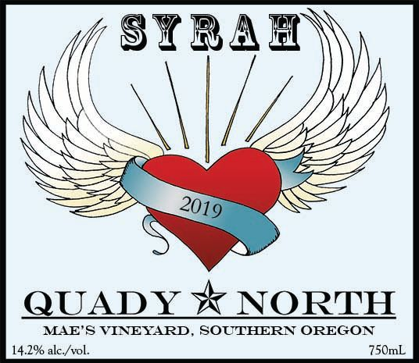
Total Production: 126 cases
Release Date: 12/2023
Suggested Retail Price: $35
Farming: Organic (certified ODA, LIVE+), Non-tillage
Winemaker Notes: The Syrah at Mae’s Vineyard is planted up the Eastern side of the vineyard, at 45 deg East of true North. As you move from the lowest part of the vineyard to the uppermost part of the vineyard, and from the 877 to the 174 clones, the character of the fruit shifts. The lower portion starts the ripening process earlier, while the upper portion tends to start later, but “catch up” so that we end up picking the two blocks within a week or so of each other. However, ultimately, the “low Syrah” results in a wine that is more about nuance and finesse, while the “upper” is about power and concentration.

Over time, we have favored using the lower block to make our “Single Vineyard” Mae’s Syrah, as we appreciate the grace that this wine shows in contrast to the upper portion, which is used in the best years for Flagship. We also love the native yeast associated with the vineyard, especially the winemaking team, who regard it as “the most well behaved” of all of the fermentations. We begin the fermentation 10 days before harvest as a “pied de terre”, picking two buckets from the block and crushing them in the field in order to incorporate the yeast present there. As the small bucket ferment progresses, we double it with additional fruit from the block, letting the native ferment build before adding it to the lot at harvest.

Tasting Notes: From our estate vineyard, this wine represents our rolling hills with a beautiful combination of fruit and baking spices. Beginning with acai fruit and coffee berries, followed by allspice and granola spices.

Date Planted: 2006

Clone: 877, 470, 174 on 3309

Fruit handling: 98% Syrah with 2% Viognier co-ferment from Mae's Vineyard

Fermentation:

