2021 “GSM”
Rogue Valley, OR
13.6% alc./vol.

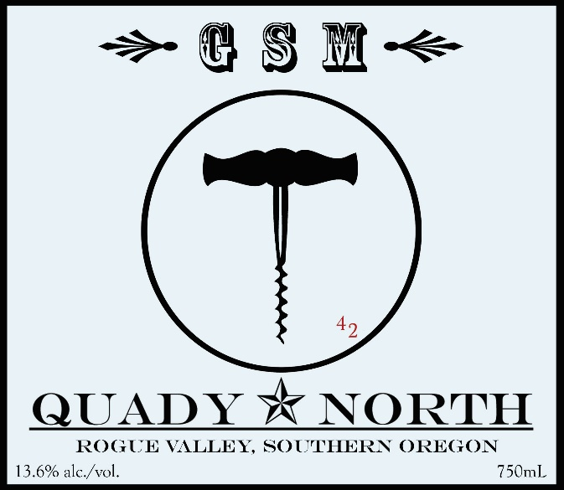

Total Production: 484 cases,

Release Date: Summer 2023

Suggested Retail Price: $27/bottle
46% Grenache, 38% Syrah, 16% Mourvedre

Winemaker Notes: We love our GSM program. As true Rhône aficionados, we are striving to emulate our favorite wines from this region, the sturdy, rustic, everyday drinkers that go so well with food. 2021 was a very warm year with relatively low yields and an early harvest.

Tasting Notes: Round, with earth and spicy notes including cardamon. Elephant heart plum.

Vineyards: Principal sources are Longwalk Vineyard (Rogue) for Grenache and Syrah, Swallow Hill (near Ashland) for Grenache, Mae’s, Layne and Steelhead Run for Syrah (Applegate Valley) and Adamson for Mourvedre.

Fruit Handling: 100% whole berry, cold soaked 48 hours
Fermentation: Fermented in small, 1 ton tanks, punched down, gently pressed at 0 B.
Aging: Racked to barrel day after pressing. Aged in large, 92 gallon neutral French Oak barrels and 58 gallon barrels, 20% new. Lees stirred regularly throughout the first quarter. Bottled unfined and unfiltered.

