2021 Syrah 4-2,A
Rogue Valley, Southern Oregon
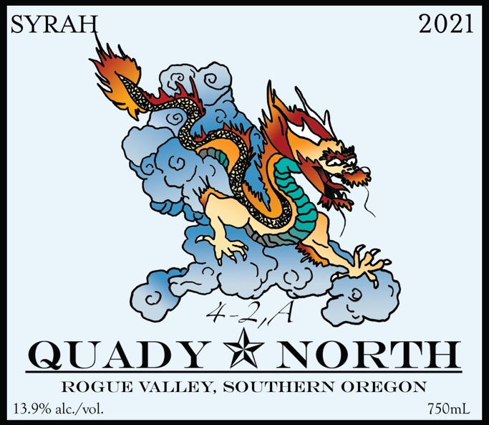

Total Production: 489 cs
Release Date: summer 2023
Suggested Retail Price: $27
Composition: 88% Syrah, 11% Grenache, 1% Viognier

Alcohol: 13.9%

Winemaker Notes: “4,2-A” is a blend of Syrah from the Longwalk, Castellano, Layne, Mae’s, Steelhead Run, and Sam’s Valley Vineyards. Each of these vineyards is LIVE or Organically farmed. Longwalk, in the central Bear Creek valley, gives a lovely mid-palate plushness. Steelhead Run contributes a garrigue note, while Castellano and Layne provide structure.

Larger barrels are favored for their more subtle oak contribution and slower aging properties preserving fruit and terroir. The name “4-2,A” was coined by our young daughter Margaux. 4-2,A or “fortooay” (think Cabernet, Chardonnay, Viognier) was the varietal name she gave to her own impromptu blends of water and fruit juice.

Tasting Notes: The 2021 shows dark fruit and supple texture. Aromas include black cherry, chocolate, and some roasted notes. The texture is substantial but has balanced tannins and nice acidity.

Fruit Handling: Destemmed with primarily whole berries, cold soaked 48 hrs.

Fermentation: Fermented in small, 1 ton and 2 ton tanks, punched down, gently pressed at 0 B.

Aging: Aged in 92 gal, and 60 gal French Oak barrels. Demptos, Meyrieux and Francois Freres, 20% new. 80% 1-3 yr. old. Lees stirred regularly throughout the first quarter. Bottled unfined and unfiltered.

