2021 La Battalla
Rogue Valley, Southern Oregon
13.7% alc./vol.
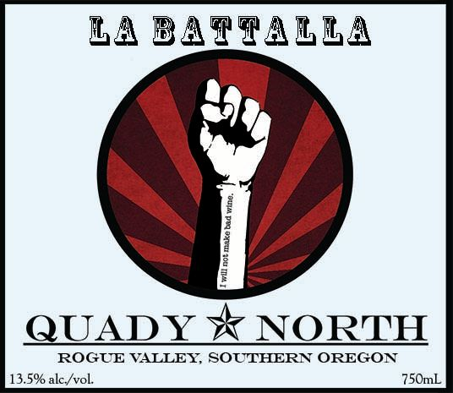
Blend: 85% Cabernet Franc, 15% Malbec
Total Production: 420 cases
Release Date: summer 2023
Retail Price/bottle: $22
About the wine:
Amongst the “fighting varietals” there exists a grand “battalla,” as various versions of vinifera compete for the hearts and minds of the populace. With this bottling, we proudly profess our preference for that alternative Cab, namely the forthright Franc. No fake fermentations here, we went old school, co-mingling whole clusters of Malbec at crush, and using native yeast. We think that you’ll find that this bottling of Cabernet Franc stands counter to the currant and resists the tyranny of tannin.
Winemaker Notes:
Fruit Handling: Malbec and Cabernet Franc co-fermented. The Malbec was left whole cluster and the Cabernet Franc was destemmed whole berries.
Fermentation: The wine was fermented in 1.5 ton open top fermenters using native yeasts (uninoculated). The wine was pumped over, and then punched down 2-3 times per day and pressed when the tannins were extracted but supple.
Aging: Aged 10 months in neutral French Oak barrels. Lees stirred throughout the first quarter.
Tasting Notes: Bing cherry, black pepper, chocolate. Moderate tannins and a smooth finish.

